**Weekly report**

*Work on transfer learning*

Successfully transferred from a neural network with ten outputs to a network with 30 outputs yielding 95% accuracy. This must now be compared with training for 30 outputs from scratch.

Below is the training graph for training on ten outputs for the usual CNN structure. In addition is the training graph for retraining the last layer.

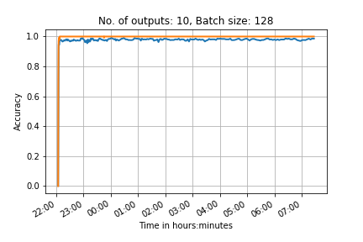

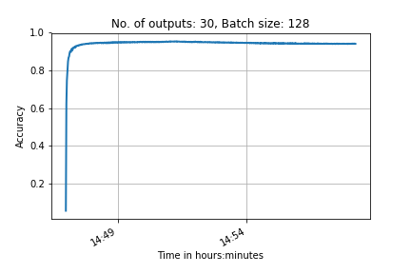

Work on Neural network class

Neural networks are now easy to build using the class that Seb finished. The class has been successfully implemented numerous times.

**Action points for the next week**

1. Carry on working on visualising the feature maps of our neural network for 100 outputs .

2. Train a network for 30 outputs to compare with transfer learning

3. train a network for 100 outputs and transfer learn to 3866 outputs